Kerry Amateur Radio Group Marconi Day 2015

Members of KARG participated as an award station in International Marconi Day 2015, from Coláiste Bhréanainn in Ballybunion by kind permission of the Coláiste committee. The Coláiste is located on the site of the original Marconi Radio Station in Ballybunion Co. Kerry, from where the very first east to west transatlantic wireless telephonic communication was made in March 1919, using the callsign YXQ.
Communication was attempted in one direction only with the sending apparatus located at Ballybunion and the receiving apparatus at Louisburg, Cape Breton, Nova Scotia.

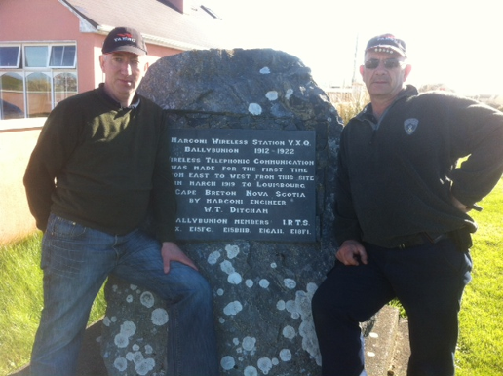
Declan EI9FVB and Billy EI7CQB at the plaque commemorating the former Marconi wireless station in Ballybunnion, Co. Kerry

It has been over a decade since radio amateurs in County Kerry last activated this Marconi site and the KARG made a concerted effort to put two stations on the air this year and hopefully we can put on more stations next year. Radio amateurs in county Kerry previously put a lot of effort into getting a station on the air in the past and many fond memories are with us of those years. Alas, not all are still with us, but those of us who have previously activated this station are very thankful of the kindness shown to us by our fellow radio amateurs. A special mention must be made of the late John O'Carroll EI6AH who treated us all like royalty in his efforts in establishing a very successful event at this location in times gone by.

Members of KARG successfully ran two stations for the full 24 hour durations of the event, using callsign EI1K, with lots of nice DX worked, including VK, ZL, VP9, VU, VE and west coast US.
Approx 68 countries were worked in the 24 hr period of the event.

It was also nice to work many other Marconi Award stations, and in particular the one from Bologna, the birthplace of Marconi.
One station ran on 40M and 80M bands using a G5RV antenna, while another ran on 20-10M bands using a Cobwebb antenna
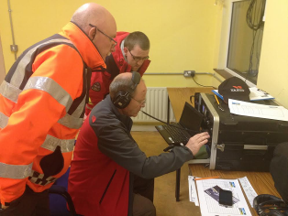
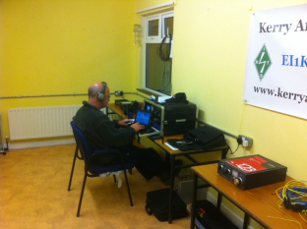
Billy EI7CQB happily working 40M Band John EI3JR working 40M Band

The local community was also very supportive of the Marconi Award station, as we had visits from members of the local Sea & Cliff Rescue, Irish Coastguard and Fire Service. All expressed great interest in our activities, culminating in KARG being presented with a certificate of appreciation by the Irish Coastguard, for running the event, and highlighting the importance that this Marconi Radio Station had, to Ballybunion and its surrounding areas.

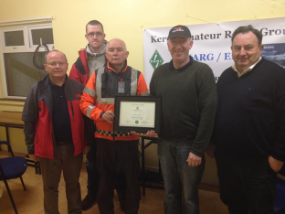
Presentation by the Irish Coastguard to KARG

Further information on the former Marconi station at Ballybunion can be found at http://www.kerryamateurradiogroup.com/marconi-station and the QRZ page for EI1K

